Step 0 Intake + Interview Filing Status, Dependency

Interview Notes: (See also: General Notes)
1. The McCooks own a home. They paid $11,000 in property taxes for the year. Block: 49 Lot: 2. They are eligible and file a homestead benefit application
2. They do not have a Mortgage.
3. Troy McCook is a Veteran
4. Robert McCook is still in High School.

Documents:
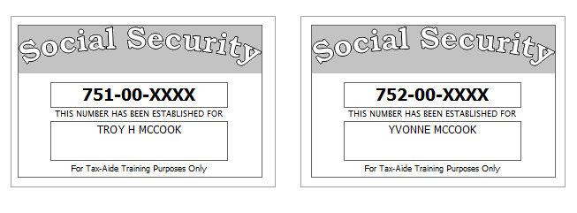

Step 1 Basic Information

TP Form / Note | TS Screen | Notes
SS Card | Start a New 2018 Tax Return  Available Taxpayer Profiles | Ignore the Profiles  Select “Enter Social Security Number” at the bottom of the screen  Enter the TP SSN twice and “Start Return”
Intake Sheet | What is your filing Status? | Answer: Filing Status: Married filing jointly  Continue
SS Card  Intake Sheet | Personal Information  Taxpayer Information  Spouse Information  Address & Phone Number | TS: Enter all information using “Caps Lock”.  Hint: Use Name and SSN from SS card. (Not Intake Sheet)  Hint: SSN format YYY-00-0752  TS: Birth date can be entered using drop down menu or filling in the field.  TS: Check any of the “Check here” questions that apply  - Check presidential election campaign fund for Spouse  TS: Spouses last name auto populates when field is selected. Change if required.  TS: Enter Zip code- TaxSlayer fills in city and state. Correct if required  TS: New Jersey automatically populates as the Resident State  TS: “Continue”
Intake Sheet  G- Note 2 | New Jersey Return  NJ Property Tax Credit or Deduction  Do you meet Property Tax  Credit or Deduction  Eligibility Requirements?  Taxpayer NJ Health Insurance  Does the Taxpayer have  Health Insurance?  Does the Spouse have  Health Insurance?  New Jersey Return  Select the County or  Municipality of your  current residence | Hint: Begin NJ Checklist  TS Answer: At this point answer “No”. We will go back and adjust after the Federal Return is complete  TS Answer: “Yes”  TS Answer: “Yes”  Use “NJ Municipality Code lookup in Tax Prep 4 Free  Left click in the box. Type in Passaic. Scroll down to PASSAIC – PATERSON CITY  At this point just hit ““Continue”” We will go back and adjust after the Federal Return is complete
Intake Sheet | Dependents/ Qualifying Person(s)  Do you have any Dependents or Qualifying Person(s) to claim on your return? | TS: Answer is “Yes”.
I-Note 4 | Dependent/Qualifying Child  Information | Add dependent information  Hint: Use name and SSN from SS card (Not Intake Sheet)  TS: The last name auto populates. Change if required  Answer: SSN format = YYY-00-0752  TS: Was this person a U.S. citizen, U.S. national, or U.S. resident alien? (See Pub. 519 for the definition of a U.S. national or U.S. resident alien) If they were not, you can’t claim the child tax credit or the credit for other dependents for this person. *  - Answer Yes  Check the “Check all that apply” questions that apply  - Robert is a full-time student, but he is not over 18  .TS: “Continue” – “Continue”

Federal AGI: 0 Federal Refund: 0 NJ Refund Amount: 0
Step 2 SSA-1099 Troy & Yvonne McCook
TP Form / Note | TS Screen | Notes
SSA-1099 | Left Menu -Federal Section-Income  IRA/Pension Distribution Form 1099-R/RRB/SSA  - Begin  Social Security Benefits/RRB-1099 -Begin | Enter SSA-1099 Data for TP and SP  Hint:  Hint: Use TP4F Scratch Pad to document Medicare Parts B, C, D. Insert total in “Taxpayer’s Medicare Premiums”. Amount = $1,619  TS: Continue, Continue

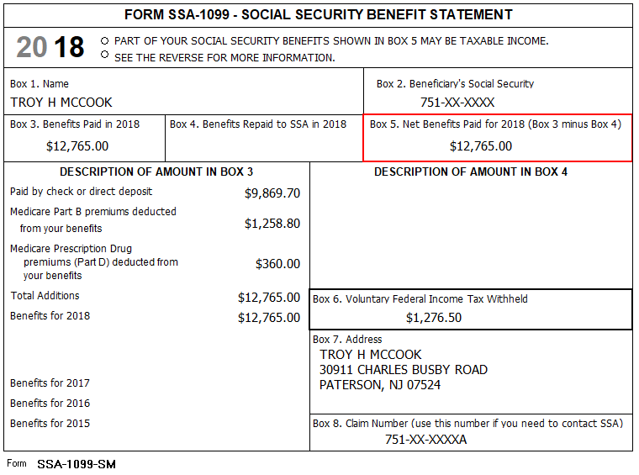

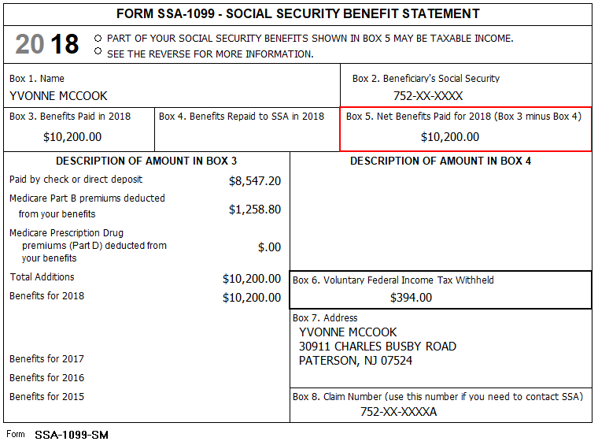

Federal AGI: 0 Federal Refund: 1671 NJ Refund Amount: 0

Step 3 Dividends 1099-DIV - Oppenheimer
TP Form / Note | TS Screen | Notes
1099-DIV  Oppenheimer | Left Menu- Federal Section -Income  Interest and Dividends Form 1099-INT/1099-DIV –  Begin  Interest or Dividend Income – Begin  Dividend Income, Form 1099-DIV-Continue | Hint: Select for Taxpayer  Hint: Payer’s EIN and address is not required  Enter values that apply  “Continue”

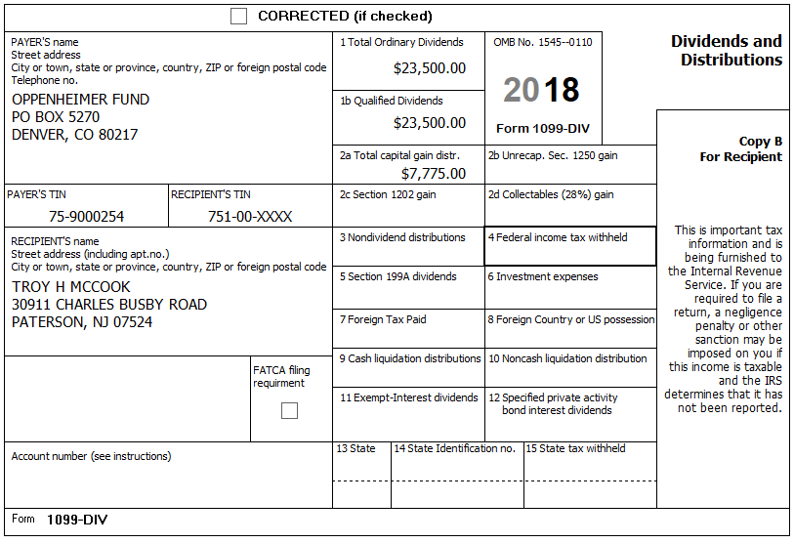

Federal AGI: 36,654 Federal Refund: 1,671 NJ Refund Amount: 0

Step 4 1099-R Ameritech

TP Form / Note | TS Screen | Notes
1099-R  Ameritech | Left Menu-Federal Section – Income  IRA/Pension Distribution Form 1099-R / RBA, SSA – Edit  Add or edit a 1099-R  Begin | Hint: “This 1099-R is for Troy  Hint: Make corrections so that information matches the information on the 1099-R  Hint: Taxable amount defaults to Gross Distribution Amount. Adjust as required.  Hint: Did you check the Taxable Amount Not Determined Box?  TS: You do not have to select a State for income to go to the State return.  TS: Save & Enter Another

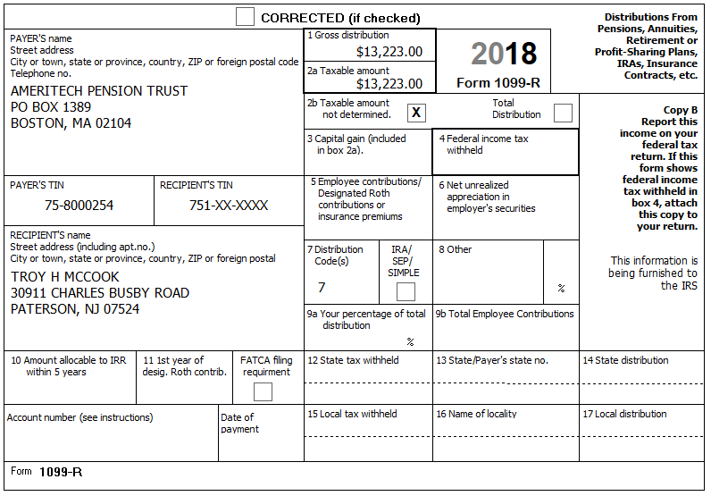

Federal AGI: 60,682 Federal Refund: 1,671 NJ Refund Amount: 0

Step 5 1099-R Phoenix

TP Form / Note | TS Screen | Notes
1099-R  Phoenix Investments | Add a form 1099-R/Pension Distribution | Hint: “This 1099-R is for Yvonne  Hint: Make corrections so that information matches the information on the 1099-R  Hint: Taxable amount defaults to Gross Distribution Amount. Adjust as required.  Hint: Did you check the IRA/SEP/Simple Box?  TS: You do not have to select a State for income to go to the State return.  TS: “Continue”

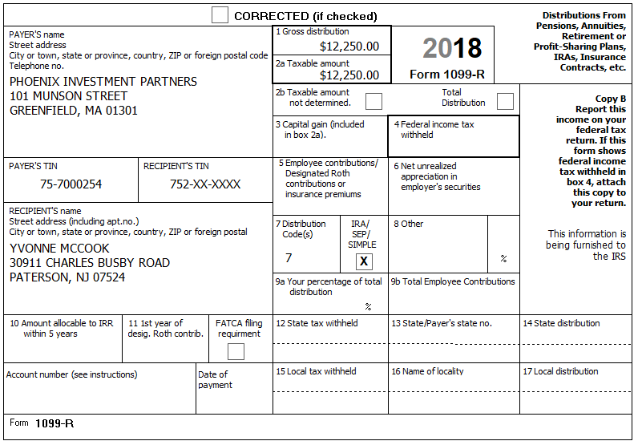

Federal AGI: 76,268 Federal Refund: 1,671 NJ Refund Amount: 0

Step 6 Itemized Deductions – Taxes You Paid
TP Form / Note | TS Screen | Notes
I-Note 1 &2 | Left Menu-Federal Section -Deductions – Enter Myself  Itemized Deductions – Begin  Taxes You Paid - Begin | TS: Go to ADD SALES TAX WORKSHEET and enter ZIP Code and 365 days living in NJ  TS: Continue - Continue  TS: Enter real estate taxes paid  “Continue”

The McCooks own a home. They paid $11,000 in property taxes for the year. They do not have a Mortgage

Federal AGI: 76,268 Federal Refund: 1,671 NJ Refund Amount: 0
Step 7 Compare Standard vs Itemized Deductions

TP Form / Note | TS Screen | Notes
 | Federal Section  Deductions  Enter Myself  Compare Deductions - Begin | Check to see if using itemized deductions or standard deductions.  Itemized = 10,000 (taxes are capped at $10,000)  Std = 26,600  Hint: You can view Schedule A (Itemized Deductions) by clicking on the Print Icon next to Itemized Deductions in the Deductions Menu.  “Continue”

Federal AGI: 76,268 Federal Refund: 1,671 NJ Refund Amount: 0
Step 8 Health Insurance

TP Form / Note | TS Screen | Notes
G-Note 2 | Left Menu-Health Insurance  Health Insurance Questionnaire  Did you or your family have health insurance or qualify for a coverage exemption at any time in 2018?  Did you purchase insurance via HealthCare.gov of a State Marketplace?  Verify Your Household Members  “  Months Insured  Was your entire household covered by qualifying health care coverage or a coverage exemption that covered 2018 or a combination of qualifying health care coverage and coverage exemptions for every month of 2018? | Answer questions in the Health Insurance Section  TS: Yes  “Continue”  TS: No  “Continue”  TS – Always select ““Continue””  TS-Yes  “Continue”

Every person on the return had health insurance that met Minimum Essential Coverage rules for the entire year. They did not purchase it through the marketplace.

Federal AGI: 76,268 Federal Refund: 1,671 NJ Refund Amount: 0
Step 9 New Jersey Return
TP Form / Note | TS Screen | Notes
I-Note 1  G-Note 2,3,4 | State Return –Edit  Basic Information - Edit  Credits - Begin  - Property Tax Credit/Deduction-Begin | Hint: Use the NJ Checklist to enter NJ items  TS: Check Basic Information –  - Dependent is covered by health insurance  - TP is a Veteran  - Gubernatorial Election Fund: Troy – No, Yvonne - Yes  Save  Hint: Taxpayer meets Property Tax Eligibility Requirements  Hint: Property Taxes Paid = $11,000  Hint: TP was a Homeowner in 2018  Hint: They were eligible and filed for homestead benefit  Hint: County Property located in: Passaic County-Paterson City  Save back to the beginning of the State Return

They had no out-of-state purchases on which they did not pay Use tax
The McCooks own a home. They paid $11,000 in property taxes for the year. Block: 49 Lot: 2.
They are eligible and file a homestead benefit application

Federal AGI: 76,268 Federal Refund: 1,671 NJ Refund Amount: 0
Step 10 Prepare for e-file
Intake Sheet  G Note 5 | Left Menu – e-file –  Federal Return Type  Fees  State Return Type  Third Party Designee Info  Consent to Disclose  Questions  Taxpayer ID Information | TS – Clear up any diagnostic messages (if any)  TS: Select Federal Return Type “E:file: Paper Check”  Next  TS: No entries in Fees section except for Client email address  Next  TS: Select State Refund Type “E:file: Paper Check”  Next  TS: Skip Third Party Designee. It is Out of Scope for us.  Next  TS: Consent to Disclose Tax Return Information – Check GRANT  and enter 5 digit pin (any 5 digit number) and date for TP and SP  Next  TS – Questions – Answer questions from Intake sheet Part VII, lines 5.6,7 and 8  - Assume taxpayer was present  Next  TS: Skip TP ID Information Screen. Not required for NJ.  Save  You are Done

They want to handle any state refund / amount due like their federal refund / amount due

Federal AGI: 76,268 Federal Refund: 1,671 NJ Refund Amount: 0

